print("Simple Question and Answering Program")
print("=====================================")
print(" You may ask any one of these questions")
print("Hi")
print("How are you?")
print("Are you working?")
print("What is your name?")
print("what did you do yesterday?")
print("Quit")
while True:
question = input("Enter one question from above list:")
question = question.lower()
if question in ['hi']:
print("Hello")
elif question in ['how are you?','how do you do?']:
print("I am fine")
elif question in ['are you working?','are you doing any job?']:
print("yes. I'am working in KLU")
elif question in ['what is your name?']:
print("My name is Emilia")
name=input("Enter your name?")
print("Nice name and Nice meeting you",name)
elif question in ['what did you do yesterday?']:
print("I saw Bahubali 5 times")
elif question in ['quit']:
break
else:
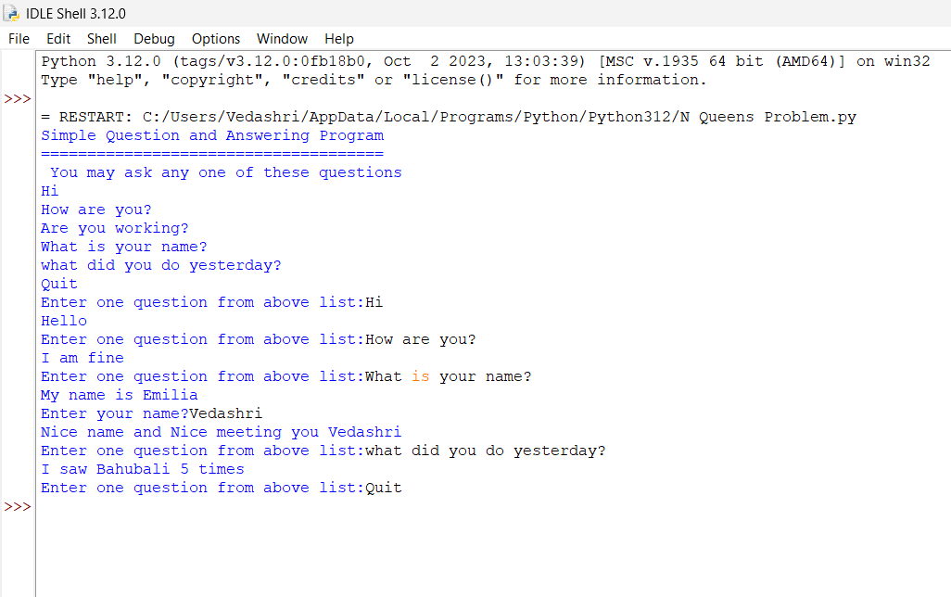
print("I don't understand what you said")

